**Name: M Afzal**

**Member ID: 22027782**

**7PAM2000 Applied Data Science 1 Assignment 1**

**Data Source:** [**https://www.data.gov.uk/dataset/7d866093-2af5-4076-896a-2d19ca2708bb/transaction-data**](https://www.data.gov.uk/dataset/7d866093-2af5-4076-896a-2d19ca2708bb/transaction-data)

**Dataset Description:**

The dataset we got for analysis has all sorts of applications from a bunch of different account holders. So basically, it arranges each row to display a cool customer account, and then the columns next to it list numbers for different types of forms like FR, DFL, TP, DLG, and stuff like that. It's super easy to get how customers use different app services when you check out this detailed description.

The "Total" column is pretty important. It like, adds up all the different types of apps for each customer. This cool feature lets you check out what your customers are up to and see how they're using your apps and what they dig about them.

Just by checking out this dataset, you can discover some cool stuff about which apps people are really into right now. It helps figure out what customers are into. It's like, used in market research and stuff to divide customers into groups. Yeah, it also helps businesses improve their services or products for their customers.

The dataset is super easy to use for data visualization because it's got all sorts of info like categories and numbers. There are like, all sorts of charts. Line plots are all about trends, bar charts are for comparing data, and pie charts show how things are spread out. Visuals can actually make data easier to understand. They give you like; really clear insights that can totally help you make smart decisions.

**Visualization 1: Line Plot (Trend of Application Types Over Time)**

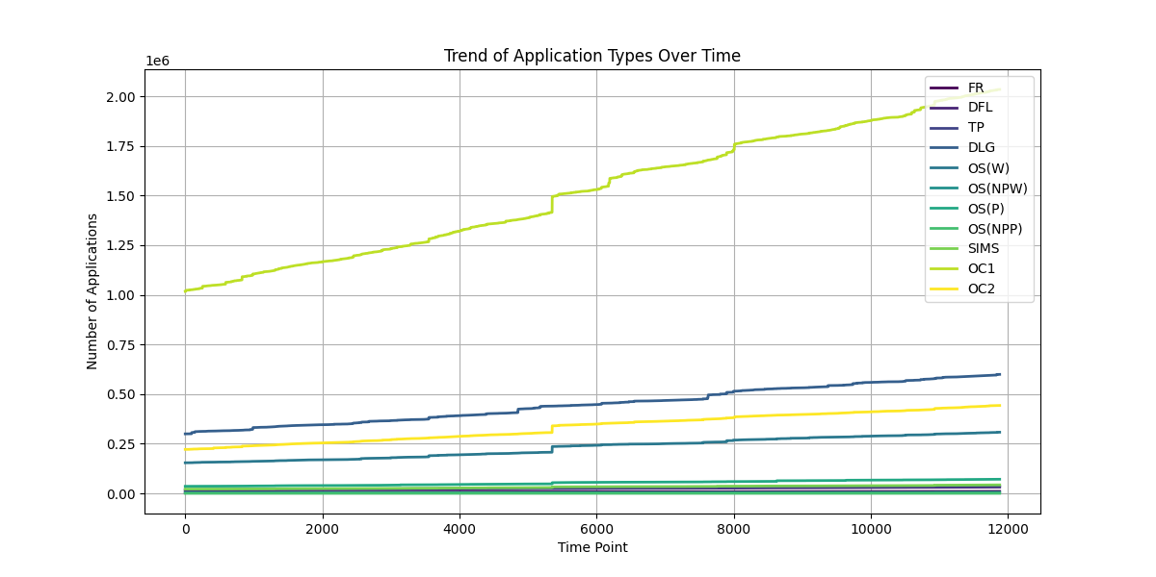

**Explanation:**

The line plot shows how the types of apps changed over time in a super clear way. So, like, each line is a different colour and it's, like, for a different type of app. The plot is all about how the number of each type of entry changes over time. The slope of each line shows how fast applications of that type are going up. A steeper slope means more apps are like, growing super fast. You can check out the lines to see which apps are popular and getting bigger.

Check out this graph that shows which apps are growing and which ones are staying the same. It's helpful.

**Visualization 2: Bar Plot (Total Number of Applications for Each Type)**

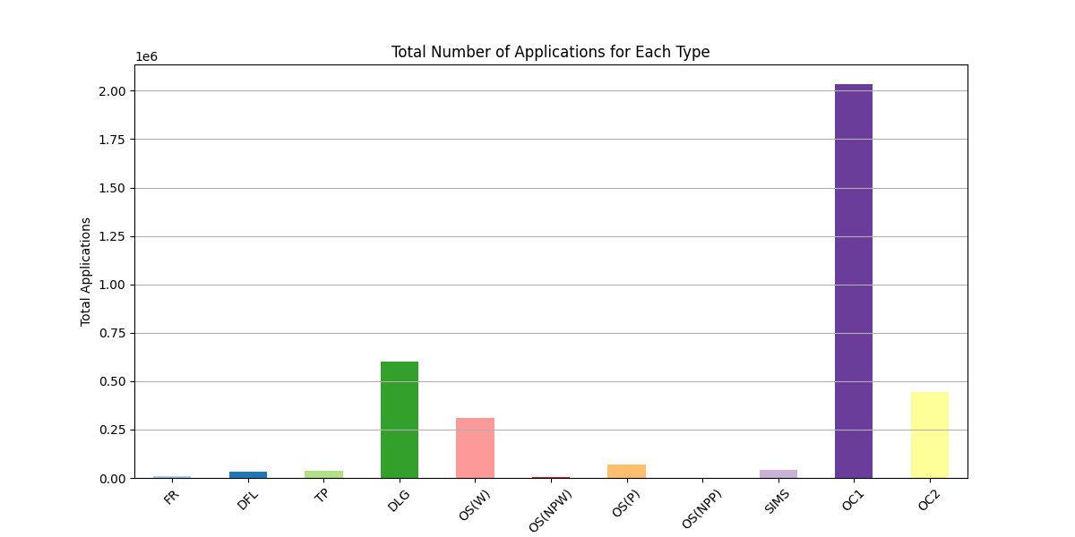

**Explanation:**

The cool bar chart shows how many files of each type there are in total. The cool thing about the different colours of each bar is that it makes it way easier to see the different types of applications. So basically, the length of each bar tells you how many applications have been made for that type in total.

* Here's what I noticed: The chart shows which programme types are the most and least popular, so it's easy to see. The different bar heights make it clear how applications are spread out among the different types.
* This cool visualization is super helpful for finding apps that might need more attention or resources. It shows which ones are used a tone or hardly at all.

**Visualization 3: Pie Chart (Proportion of Each Application Type)**

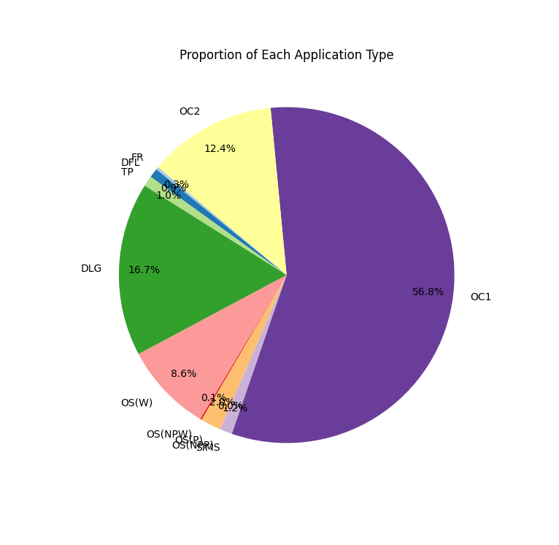

**Explanation:**

So basically, the pie chart is all about how the different types of applications are spread out compared to the total number of applications. Pretty cool, huh? Each section has a different colour, and the percentages are shown clearly to make it easier to read. This chart shows you how each app type fits into the bigger picture of apps. It's pretty helpful!

* The size of each pie slice shows how important each application type is in the whole dataset. Bigger slices mean that those programmer types are more commonly used or liked.
* This graph shows you how different applications are doing in the market and points out areas that could use some more attention or improvement.